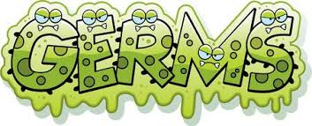

Hello, I am Germs and I am EVERYWHERE! I am at daycare, stores, schools, church, movies, vehicles, families/friends’ homes, work places, restaurants, bathrooms, and I can go on ………. If you don’t want me around you or your family than her is a list of things to do!!!
- WASHING/SANITIZING your hands everywhere you go. Proper hand washing is for at least 20 seconds or kids to say their ABC (before and after meals, blowing/wiping noses, cough & sneezing into hand, handling food)
- KEEPING FINGERS OUT of your mouth and nose
- COVER ALL coughs /sneezes with your elbow
- BLOW your nose with a tissue (not sleeves, hand, licking it or letting run down your face)
- STAY HOME when you are not feeling well! REST!!!!
- EAT AND DRINK PROPERLY push Vitamin C foods, Vitamin D, fruits and vegetables—add COLOR to your plate, -LOTS of water
- GETTING ENOUGH SLEEP and KEEP ACTIVE
- WASHING Wash your dish cloths, hand towels daily or dish scrubbers. Your child’s stuff animals could use a washing also!
Please take care of your self and families health! Stay home or keep kids home when they can not participate in daily activities

Parent Signature _____________________________________________ Date: ____________________
Provider Signature ____________________________________________ Date: ___________________

